
EDLESBOROUGH PARISH COUNCIL
February 2019
Edlesborough Parish Council Outdoor Gym Equipment Consultation

Dear Resident
Edlesborough Parish Council are currently exploring the option of installing Adult Gym Equipment in the Parish. The Council has agreed that Dagnall should be the first village to benefit from this proposal. With this in mind the Council now needs your input.
Please would you kindly complete the questionnaire below and return to the Clerk, Penny Pataky, 15 Summerleys, Edlesborough, LU6 2HR by 1st March 2019.
Alternatively questionnaires can be downloaded from the Edlesborough Parish Council website, www.edlesborough-pc.gov.uk and returned via email to clerk@edlesborough-pc.gov.uk

Below are typical examples of Adult Gym Equipment. We are looking to place between 4-6 pieces along the back fence of Dagnall Recreation Ground.

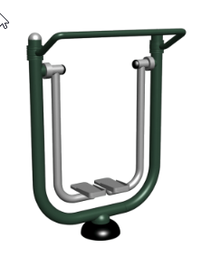  Air Walker | 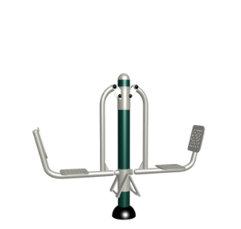  Seated Leg Press
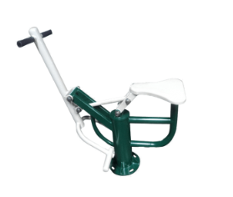  Adult Rider | 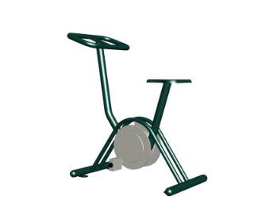  Classic Cycle
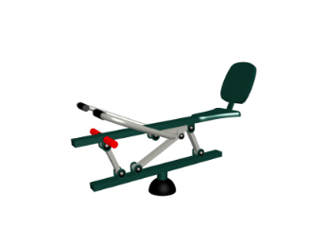  Self-Weighted Rower | 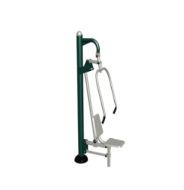  Seated Chest Press
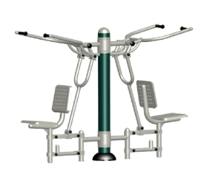  Pull Down Challenger | 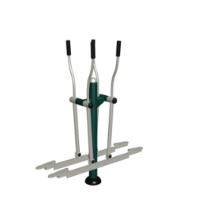  Cross Country Skier

- Please indicate your age band
 | Resident 1 |  | Resident 2 | Resident 3 | Resident 4 | Resident 5
0-18
19-30
31-50
51-70
70+
- Do you currently use any other outdoor gym equipment, if so where?
- Would you use adult gym equipment if it was installed on Dagnall Recreation Ground?
Please indicate yes/no/
Maybe
- Please indicate how often you might use the adult gym equipment
Never
Once a month
Once a week
2-3 times a week
Daily
- What, if anything would deter you from using outdoor gym equipment?
- How would you travel to the adult gym equipment? For example, walk, jog, cycle, drive.
- Do you currently have a membership to indoor gym facilities?
- Do you think your daily fitness activity would increase if there was adult gym equipment available in Dagnall?

Please rank the equipment in order of your preference with 8 being your favourite/most preferred and 1 you’re your least favourite. If you do not have a preference just put N/A. or alternatively please feel free to just choose your top 3-4 pieces if preferred.
Item | Resident 1 | Resident 2 | Resident 3 | Resident 4 | Resident 5
Air Walker
Seated Leg Press
Adult Rider
Classic Cycle
Self-Weighted Rower
Seated Chest Press
Pull Down Challenger
Cross County Skier

Name _____________________________________

Address _____________________________________
_____________________________________
_____________________________________
_____________________________________

Contact No. (optional) ___________________________
Email Address (optional) ___________________________

Thank you for taking the time to respond to this consultation.
Edlesborough Parish Council, 15 Summerleys, EDLESBOROUGH, LU6 2HR
Email: clerk@edlesborough-pc.gov.uk 01525 229358 Website: www.edlesborough-pc.gov.uk

